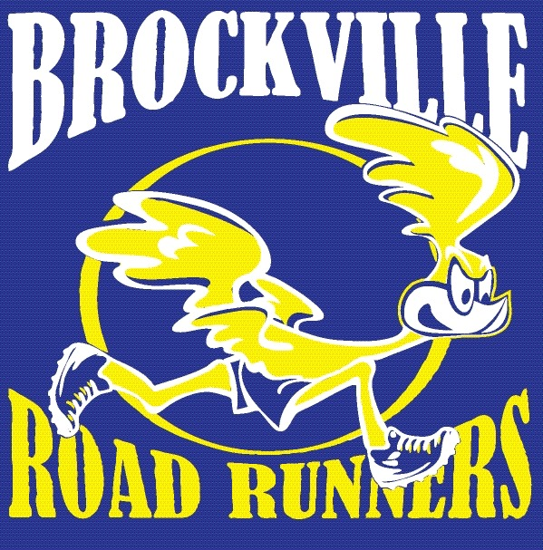
Brockville Road Runners Club

High School Student Bursary Form

(www.brockvilleroadrunners.com)

The Brockville Road Runners Club is an association that promotes active and healthy lifestyles, through participation in its organized activities. The club is not-for-profit, and prides itself with giving back to the community by supporting charities within Brockville and surrounding areas, supporting local high school bursaries and helping others in need.
To be eligible for this bursary, the Grade 12 Student(s) must be interested in pursuing or accepted into a university or college level post-secondary program and has participated in events supported by the Brockville Road Runners Club.
Please return this form to the Student Services Department at your high school, no later than May 1st for consideration. Completed form should be returned to: Liam Cullen, BRRC Secretary, 1430 McDonald Road, Brockville ON. K6V 5T3 Email: liamcullen58@aol.com

Student Information

Name:

Secondary School:

Email or Contact Information:

Post-Secondary Education Plans:

Please list how you are involved with the Brockville Road Runners Club:

_________________________________________ ___________________________________________
Signature of Applicant Signature of Principal (or designate)

